**Godwin Newsletter**

**October 23, 2015**

We are looking forward to a really busy week next week.

Thank you all for supporting the Boosterthon, the big fundraiser

of the year! The money will go for new computers.

Please see the schedule for next week from Guidance:

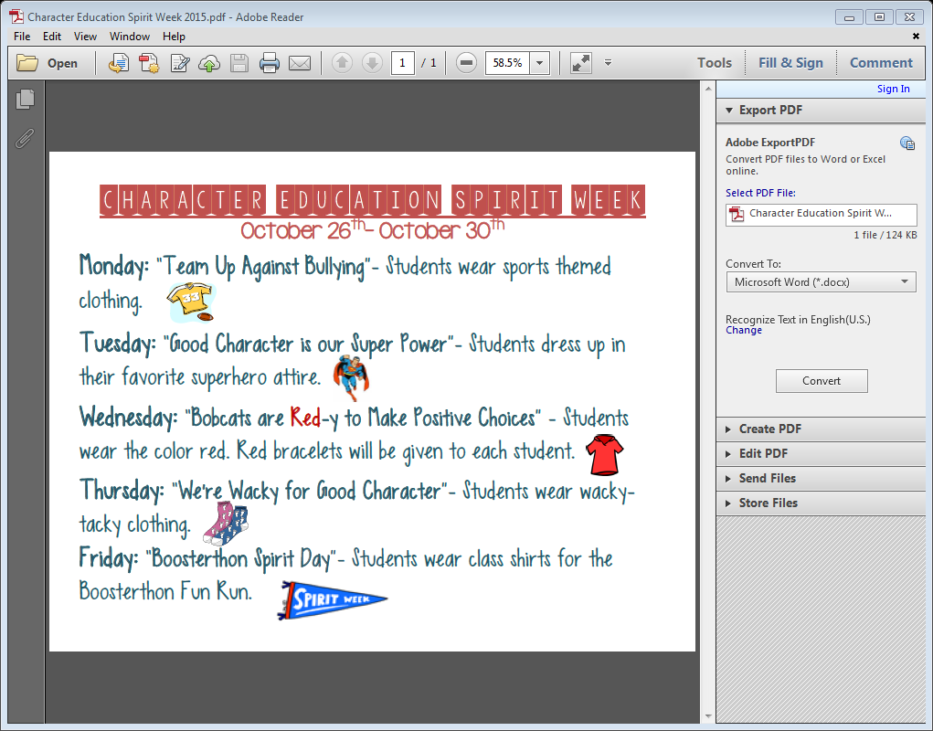

**Because we are going on our field trip on Tuesday, we will skip the Superhero outfits and wear our new blue kindergarten shirts.** Our appointment at Publix is 10:00.We are going to eat our lunches here at school, but please send a lunch from home, since we will be missing our time in the lunchroom.

On Friday, we will be running our Boosterthon Fun Run. It is a hoot and you are invited to come and be here for our time at 8:45. Each child will receive a t-shirt for the day that we will put on that morning. They will need to wear sneakers. Our Halloween party is at 1:45. No costumes, please.

Sarah Godwin